# Lifecycle Management

## Formats

For the initial regulatory activity (e.g., NDS, SNDS, ANDS, ASNDS) product monographs shall be provided in the following formats:

1. Product monograph (clean) – XML format (.xml file and associated .jpeg files)
2. Product monograph (clean) – Word format (.docx file)
3. Product monograph (annotated) – Word format (.docx file)

For regulatory transactions submitted during review (e.g., response to request for clarification) product monographs shall be provided in the following formats:

1. Product monograph (clean) – Word format (.docx file)
2. Product monograph (annotated) – Word 2010 format (.docx file)

For final regulatory transactions (e.g., Pristine sequence following a Notice of Compliance (NOC)) product monographs shall be provided in the following format within 20 calendar days:

1. Product monograph (clean) English – XML format (.xml file and associated .jpeg files)
2. Product monograph (clean) French – XML format (.xml file and associated .jpeg files)

## Lifecycle for Regulatory Activities in the eCTD

Sponsors should use the following eCTD lifecycle attributes to manage Word and XML product monographs under the following circumstances (Refer to **Figure 1**, **Figure 2** and **Figure 3** for examples):

* ‘**NEW**’ when a clean or annotated product monograph is provided as part of the first transaction of a regulatory activity (e.g., NDS, SNDS).
* ‘**REPLACE**’ when a clean or annotated product monograph is provided in response to clarification request, screening deficiency notice (SDN), notice of deficiency (NOD), notice of non-compliance (NON).
* ‘**NEW**’ when a pristine product monograph is provided for the first time. The last clean and annotated draft product monographs should be assigned the operation attribute ‘**DELETE**’.
* ‘**REPLACE**’ when a pristine product monograph is provided to replace a previously approved pristine product monograph. The last clean and annotated draft product monographs should be assigned the operation attribute ‘**DELETE**’.

**Figure 1 Example of an eCTD lifecycle for the first regulatory activity and its transactions (e.g., NDS or ANDS)**

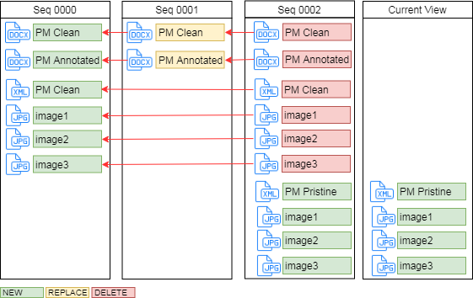

**Figure 2 Example of an eCTD lifecycle for a subsequent regulatory activity and its transactions (e.g., SNDS, SANDS)**

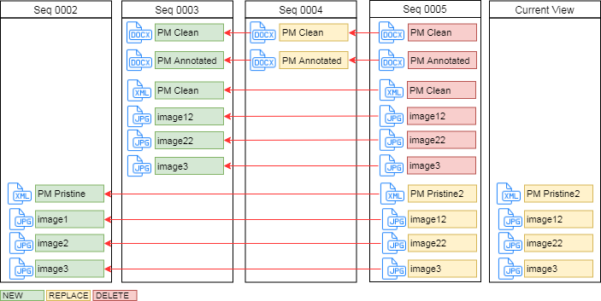

**Figure 3 Example of an eCTD lifecycle for regulatory activities under simultaneous review**

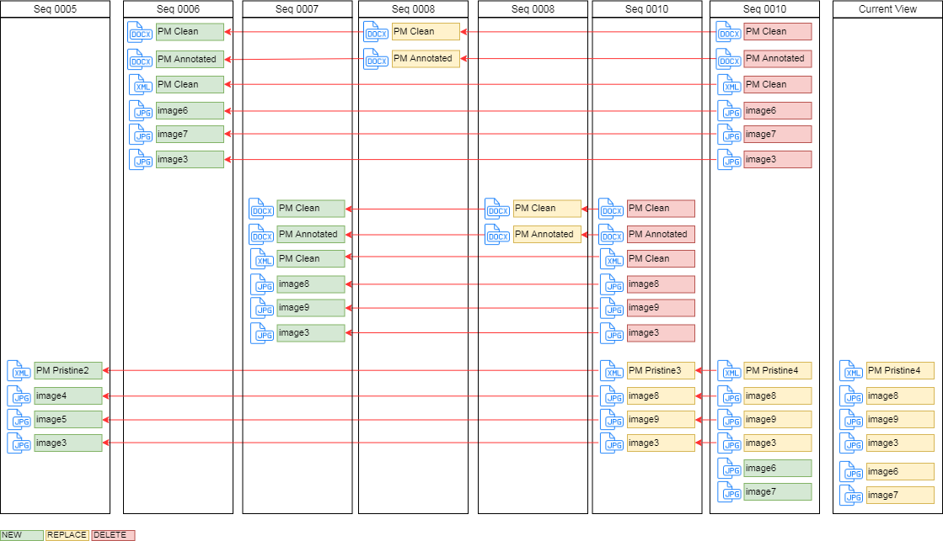

## Lifecycle for Regulatory Activities in the Non-eCTD

Unlike eCTD lifecycles, non-eCTD electronic submissions do not have XML backbones or XML attributes. Therefore, there is no document lifecycle.

Sponsors are only required to submit product monograph files in the formats outlined under section 5.1; I.e., Word and XML with the initial submission, Word only during review and XML only for the final pristine submission.